Meet Your Robot
Last week you saw how to use a pulse-width modulated signal generated by a pulseio.PWMOut to make a continuous servo motor rotate. I remind you that it requires a 50 Hz PWM signal with an on time in the range 1.3-1.7 ms and that the motor should stop if the on time is 1.5 ms.
This week you will set your robot free to roam the lab. If it is not already set up then execute the following steps to bring your robot to a working state. Use the figure below to guide you as you place components.
1) At the back of the board place the two 3-pin connectors into which you will plug the motors and plug the 2-pin battery connector into the right-side power rail of the breadboard. The blue-lined row will be ground and the red-lined will be 5V power.
2) Plug the motor wires onto the 3-pin connectors with the white wire towards the front of the robot. Wire the black-wire pins to ground and the red-wire pins to 5V.
3) Plug your Feather board into the breadboard so it just leaves room for the motor connectors.
4) Wire the Feather's ground to the board ground and the Feather's USB pin to the 5V rail.
5) Pick two PWM capable pins and connect them to the white-wire pins on the motor connectors.
At this point you can plug the Feather board into the computer with its USB cable and the USB will supply power to both Feather and the motors.

Task 1 Get Moving
Based on your work in Lab 27, create a program that can drive two servo-motors, one on each of the pins to which you wired the motors. You should be able to independently set the motor speeds as that is how you will steer your robot. Get this program running with both on-times set to 1.7 ms and verify that both motors turn (almost certainly in opposite directions!).
a) Explain the directions of the motors.
The two motors turn in opposite directions because they are mounted in mirrored orientations.

b) How will you fix this to make the robot move forward or backward?
Changing one of the on-times to 1.3 made the robot go forward, but it wasn’t exactly straight.

c) Disconnect your robot from the USB connection, plug in its battery, and verify that is sets off all by itself!
It does.

Back in Lab 27 you explored the relationship between pulse timing and motor speed for the motors in your robots. You know that there is a rather limited range of control. You now need to play with the timing of your pulses until you can find two sets of values that produce the same speed in both motors. You will need one set for each direction. I strongly recommend that you choose pulse values that are somewhat below maximum speed. That way you have some assurance that the speed is set by the controller and not by the physical limitations of the motor. You will know when the two motors are running at the same speed when the robot can drive in a straight line for a few feet (2-3 feet is about as good as you will do!).
Remember that once you have programmed your robot you can disconnect the debug cable and the program will remain in the computer and run by itself.
Record your chosen pulse times below.
Forward Left | 1.6ms
Forward Right | 1.3ms
Backwards Left | 1.3ms
Backwards Right | 1.7ms

Task 2: Roaming the world
Now, set the robot free and make it walk in a perpetual square. The robot should run forward for a few seconds and then execute a 90° turn and keep repeating that. You have achieved success when the robot can be placed on the floor and it will keep going round roughly the same square time after time.
a) Explain how you did this and discuss any problems you experienced.
I wrote functions for moving forward and backward, and turning right. I expected to be able to move in a square pretty easily, but my tires had no traction and my timing took a long time to fix.
b) Paste the, suitably commented, working program below.
# Author: Ben Kallus
# Drives a robot in a square

import board
from digitalio import DigitalInOut, Direction
from pulseio import PWMOut
from time import sleep, monotonic

MAX_DUTY = 65535

PINL = board.D10 # left
PINR = board.SCK # right
FREQ = 50 # frequency required for motors

FD_L_TIME = 1.6
FD_R_TIME = 1.3
BK_L_TIME = 1.3
BK_R_TIME = 1.7

RIGHT_TURN_TIME = .6

def calculate_duty_cycle(on_time, frequency):
# $frequency in Hz, $on_time in ms
return round(MAX_DUTY * on_time / (1000 / frequency))

def forward(fd_time, pwmr, pwml):
start = monotonic()
pwml.duty_cycle = calculate_duty_cycle(FD_L_TIME, FREQ)
pwmr.duty_cycle = calculate_duty_cycle(FD_R_TIME, FREQ)
while monotonic() - start < fd_time:
pass
stop(pwmr, pwml)

def stop(pwmr, pwml):
pwmr.duty_cycle = calculate_duty_cycle(1.5, FREQ)
pwml.duty_cycle = calculate_duty_cycle(1.5, FREQ)

def turn_right(pwmr, pwml):
start = monotonic()
pwml.duty_cycle = calculate_duty_cycle(FD_L_TIME, FREQ)
pwmr.duty_cycle = calculate_duty_cycle(BK_R_TIME, FREQ)
while monotonic() - start < RIGHT_TURN_TIME:
pass
stop(pwmr, pwml)

def backward(bk_time, pwmr, pwml):
start = monotonic()
pwml.duty_cycle = calculate_duty_cycle(BK_L_TIME, FREQ)
pwmr.duty_cycle = calculate_duty_cycle(BK_R_TIME, FREQ)
while monotonic() - start < bk_time:
pass
stop(pwmr, pwml)

def main():
pwmr = PWMOut(PINR, duty_cycle=calculate_duty_cycle(1.5, FREQ), frequency=FREQ)
pwml = PWMOut(PINL, duty_cycle=calculate_duty_cycle(1.5, FREQ), frequency=FREQ)

for _ in range(4):
forward(2, pwmr, pwml)
turn_right(pwmr, pwml)

main()

Task 3: And again, only harder!
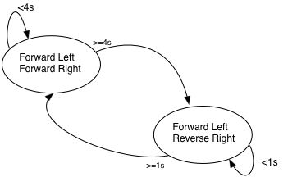
Your current program almost certainly uses a simple delay-based programming style, much as you used for the first traffic light program. Now I want you to re-write the fixed path program using the event-driven style that you used for the second traffic-light lab. We need to do this because we are going to want our robot to be able to respond to external events and we know that the event-driven style is CircuitPython's method of making that practical.
Let's start with a program that does exactly what you just did, walks round in a square. The state diagram is pretty easy, as shown on the left. We run forward for a while and then we turn for a while. You should be able to re-use the times from your delay-based program.

You might start with something that in outline looks like
while True:
now = time.monotonic()
if now > next:
if state == 0: # Have just been going forward, turn for 1 s
Rotate()
state = 1
next = now + 1000
else: # state==1, done turning, forward for 4 s
Forward()
state = 0
next = now + 4000

Convert this to a working program, tune the times, and demonstrate that your robot rolls in a square. Paste the working program, with good comments, below.

Task 4: Interacting with the Real World
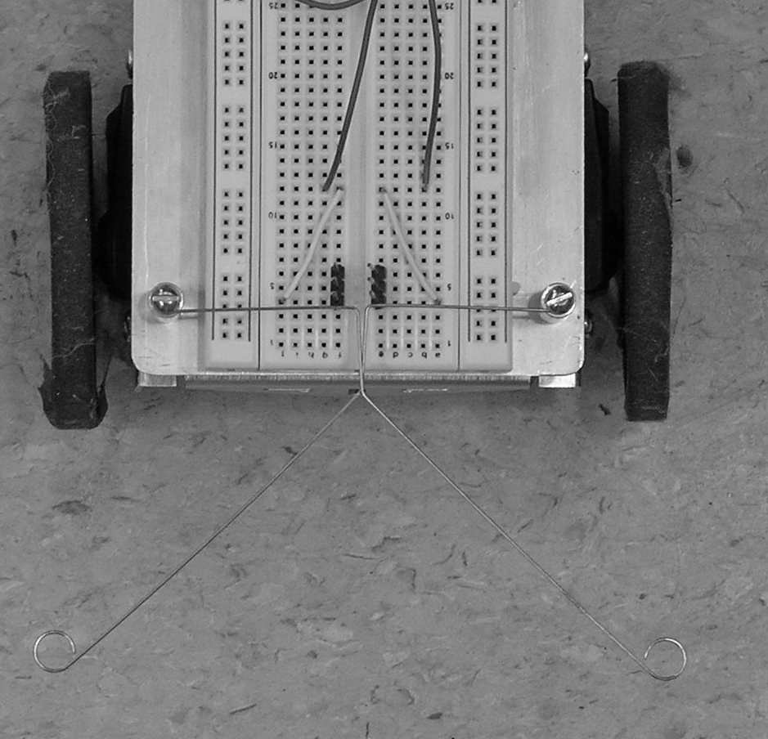
Your robot is now good at wandering the world on its own so long as nothing gets in its way. It is time to add bump sensors. I have provided you with “whiskers” of metal to attach to the front stanchions of the robot to act as bump sensors. Start by removing the screws in the tops of the stanchions and adding the whiskers as shown in the figure.
Next add the little 3-pin headers as shown. These provide the contacts between the whiskers and the computer. Carefully adjust the whiskers so that they don’t quite touch the pins but a small push on the whisker brings them into contact.
Now the whiskers are grounded because the posts to which they are connected are grounded. Thus when the whisker touches the pin the pin will be grounded. Now connect the pins to two unused digital pins. If we put those pins into INPUT_PULLUP mode then the computer will hold the pins high unless the whiskers touch them. This means that you can read the port and know whether the whisker is touching (input is LOW) or not (input is HIGH).

a) Write a simple program that sits and reads the whiskers and does something that you can verify (blinking the LED on the Feather board might be a good idea). Show that you can read the whiskers and explain how you tested their function.

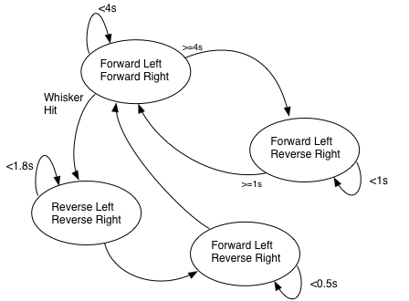

b) Now modify your program to check the switches every so often, about 1-5 times per second, and take action if they are pressed. Do this by adding states to your event driven program and to the state diagram. For example, a simple modification is shown in the adjacent figure.
When a whisker is hit, we immediately stop going forward and start going backwards. We do that for some length of time (1.8s here) before turning a small angle (rotate for 0.5s) and then going back to running the square.
I want you to add hit testing code inspired by this to your robot code. If you choose, you may distinguish between the left switch only being pressed and the right switch only pressed (it's pretty much impossible to press both at exactly the same time). For example, seeing the left switch only might cause the robot to back up slightly and turn to its right while seeing the right switch might cause it to back up and turn to the left.
Demonstrate your robot's ability to respond to collisions and paste your (commented!) program below.

